|  |
| --- |
| Cruz-Rabe Maternity & General Hospital Pharmaceutical Management System |
| System Manual |
| **Prepared by:**  **Kevin Navarro**  **Flordeliza Calanno**  **Cristine Ronario**  **Submitted to:**  **Mrs. Carmelita Buenaflor (CLIENT)**  **Mr. Joegene** |

4/24/2015

Table of Contents

**Frontend** .**3-6**

Return I tem Header3-4

Return Item Details5-6

**Backend** ..**4-52**

**User Management**7-14

User7-9

Employee…………………………………………………………………………………………………………………………10-12

Position ……………………………………………………………………………………………………………………………13-14

**Stock Inventory** ……………………………………………………………………………………………………………………………..15-25

Stock Inventory………………………………………………………………………………………………………………….15-17

Item………………………………………………………………………………………………………………………………….18-19

Generic Name……………………………………………………………………………………………………………………20-21

Manufacturer……………………………………………………………………………………………………………………22-23

Unit of Measure…………………………………………………………………………………………………………………24-25

**Stock Issue Forms**…………………………………………………………………………………………………………………..………26-31

Stock Issue Details……………………………………………………………………………………………………………26-28

Stock Issue Header……………………………………………………………………………………………………………29-31

**Return Item Forms**………………………………………………………………………………………………………………..……….32-40

Patient………………………………………………………………………………………………………………………………32-34

Return Item Details………………………………………………………………………………………………………….35-37

Return Item Header ………………………………………………………………………………………………………….38-40

**Create New Attributes**……………………………………………………………………………………………………………………41-52

Stock Status…………………………………………………………………………………………………………….…………41-42

Accounting Status…………………………………………………………………………………………………………..…43-44

Location ……………………………………………………………………………………………………………………..…..45-46

Bed…………………………………………………………………………………………………………………………………..47-49

Item Category…………………………………………………………………………………………………………..………50-52

**Frontend of Return Item Header**

The Return Item Header at the frontend of the system is for accounting department for viewing purposes for the billing of the patient.

The picture below is the view of the Return Item Headers which is the user can search for the patient name and view of what are the items that have been return by the patient. It shows the reference table 1.1

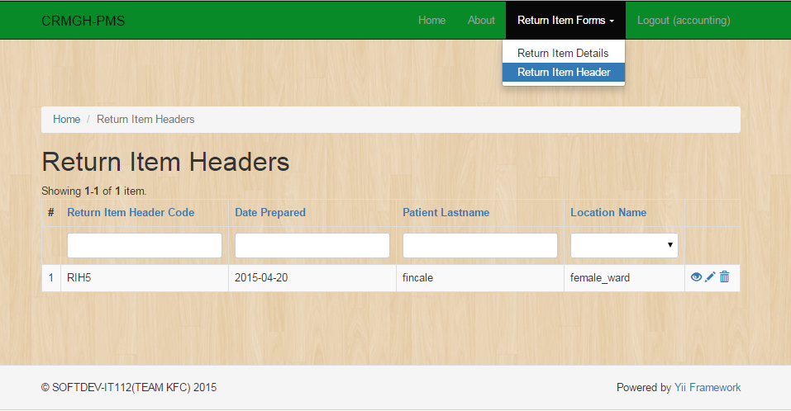

To view the details click the  , and the image below shows the details.

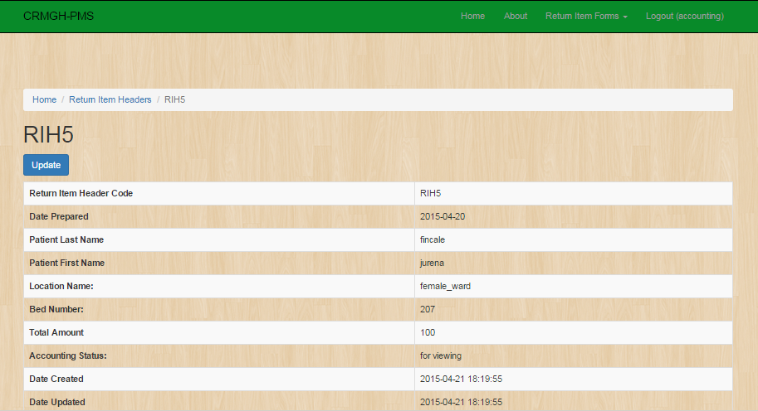

For “**Accounting**” users to update the **accounting status** of the **return item header,** click the **update** button.

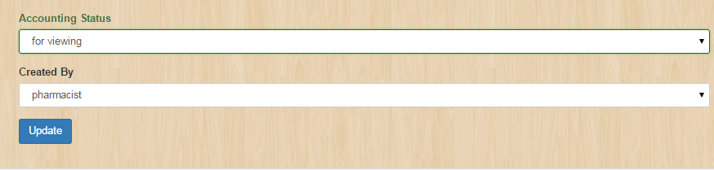

And click “**Update**” at the bottom page.

Return Item Details (frontend)

Return item details table is to manage the all the Return item details of the item.

The picture below is the view of the Return item details table which is you can create, update and delete the item you will create. It shows the reference table 1.1

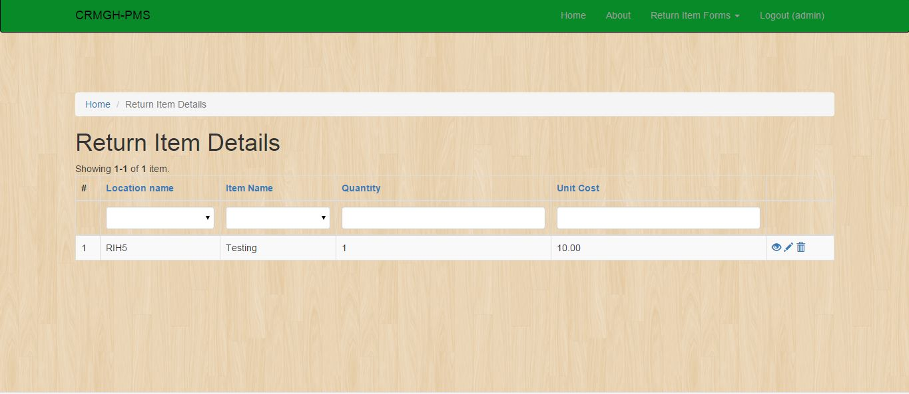

To view the details just simply click this button:



It will display this page:

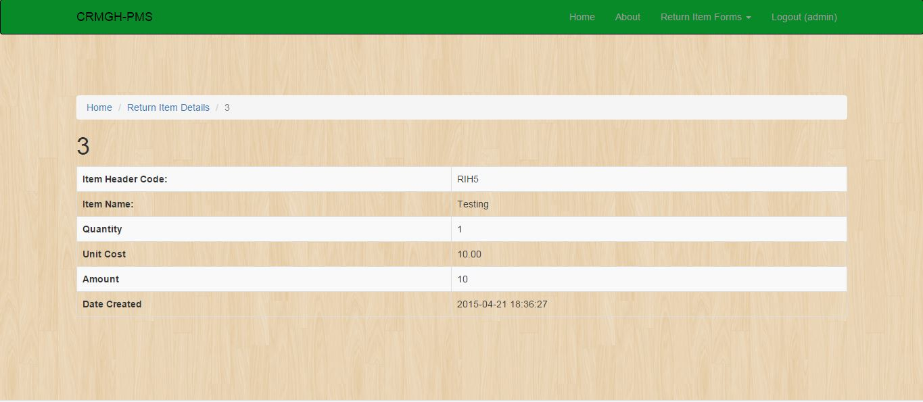

**USER MANAGEMENT TAB**

* **Users**

The picture below is the view of the Return item details table which is you can create, update and delete the item you will create. It shows the reference table 1.1

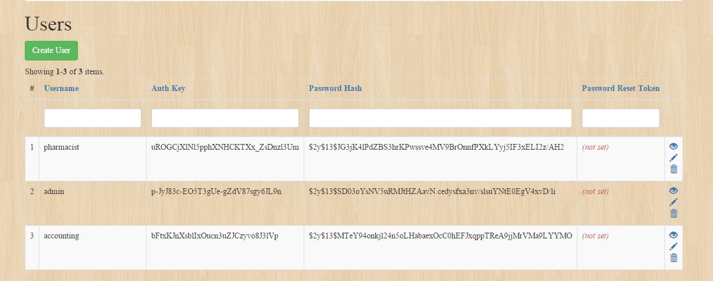

To view the details just simply click this button:



To create a User click this button



It will display this if you click the button Create User

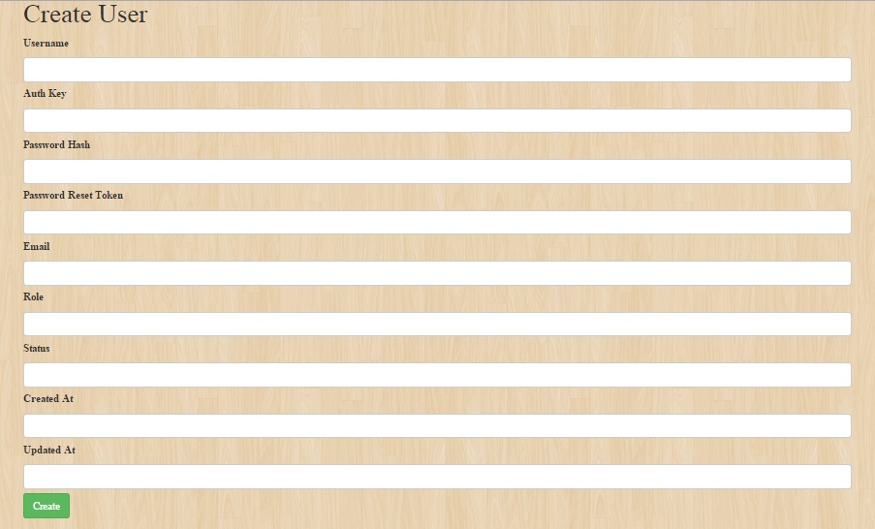

To edit or update the entity see the reference table 1.1 then click the update button.

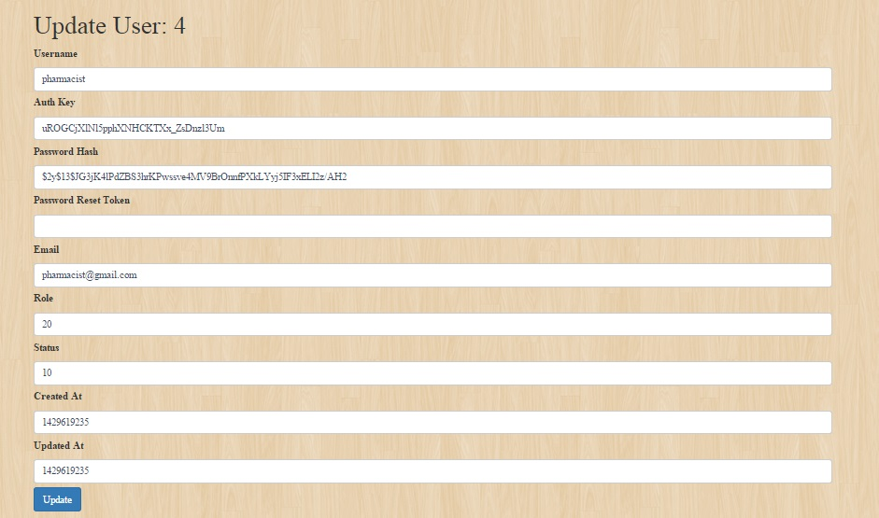

* **Employee**

**Manage Employee Records**

Under the **User management** navigation bar, go to **Manage Employee Records** and the image below should be prompted which you can create, update and delete the item you will create .It shows the reference table 1.1.

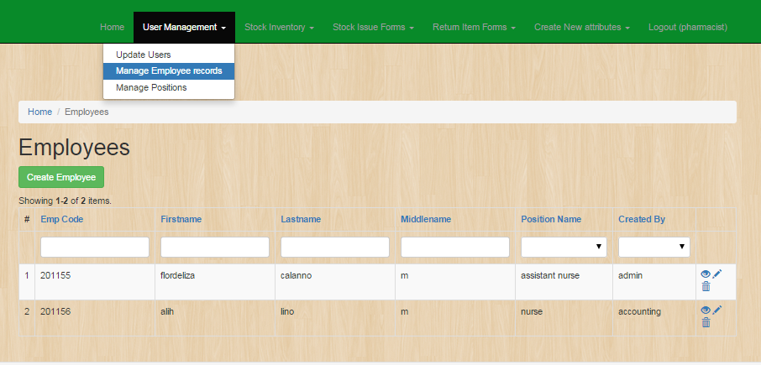

To create **Employee Record** click the button same as the image below:



And a new page like the image below would be open as you click the **create employee** button. Fill out the fields with appropriate data and click the button **create.**

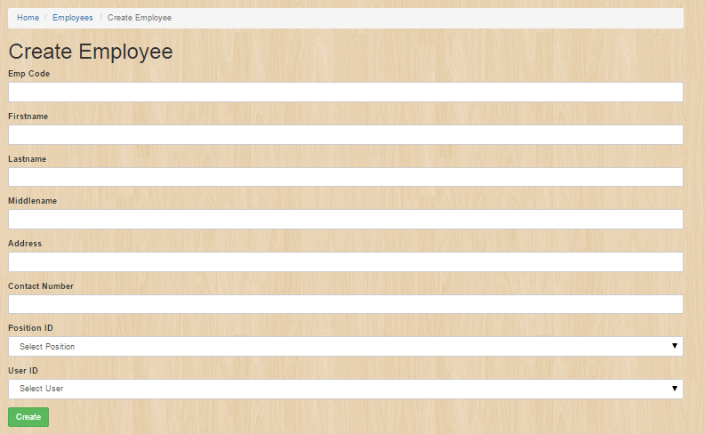

As you succesfully created employee record, an image below should be the result.

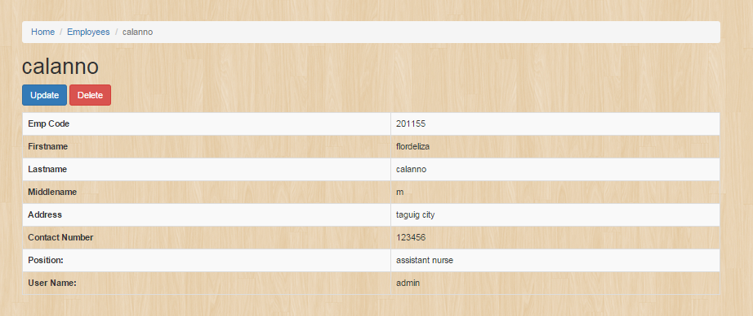

* **Position**

**Backend Position Table:**

Position table is to manage the positions for each employee.

The picture below is the view of the position table which is you can create, update and delete the item you will create. It shows the reference table 1.1

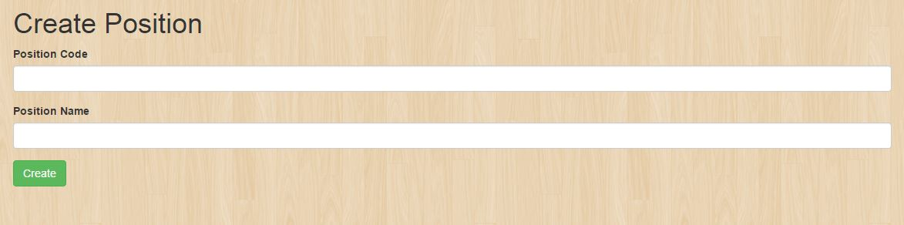

To create a Position just simply clicks this button:



It will display these fields:



**STOCK INVENTORY TAB**

* **Stock Inventory**

**Manage Employee Records**

Under the **User management** navigation bar, go to **Manage Employee Records** and the image below should be prompted which you can create, update and delete the item you will create .It shows the reference table 1.1.



To create **Employee Record** click the button same as the image below:



And a new page like the image below would be open as you click the **create employee** button. Fill out

The fields with appropriate data and click the button **create.**



As you succesfully created employee record, an image below should be the result.



* **Item**

Item table is to manage the all the item of the inventory.

The picture below is the view of the item table which is you can create, update and delete the item you will create. It shows the reference table 1.1

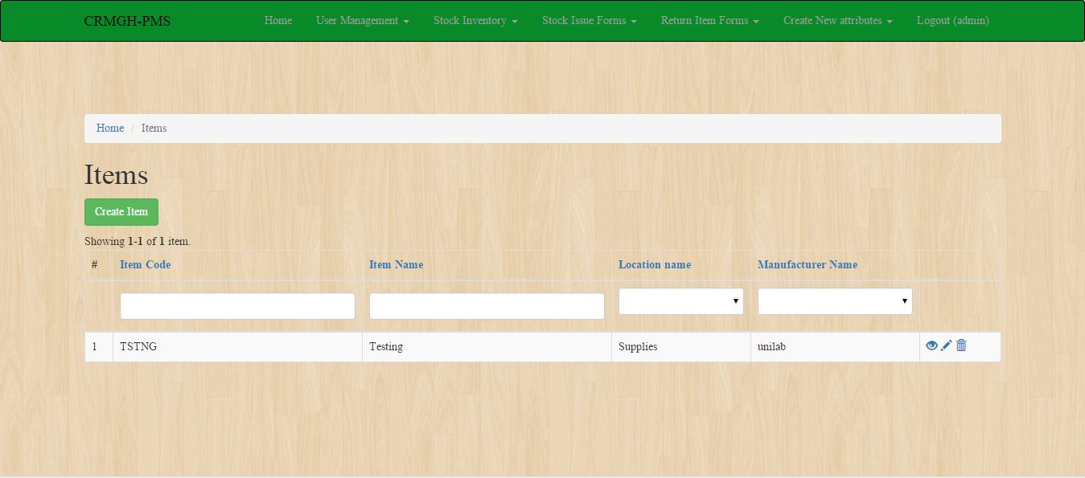

To create an Item just simply clicks this button:



It will display this page:

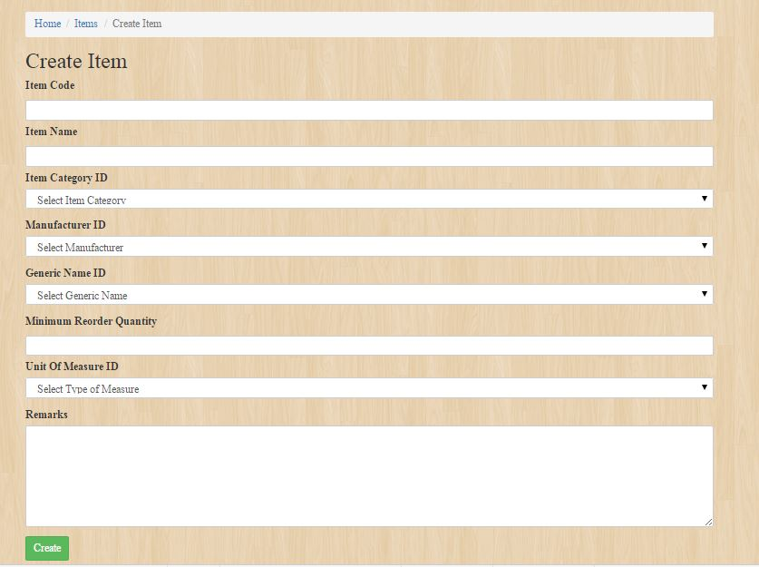

* **Generic name**

**Backend Generic Name**

The picture below is to view the patient which is you can create, update and delete the item you will created .It shows the reference table 1.1

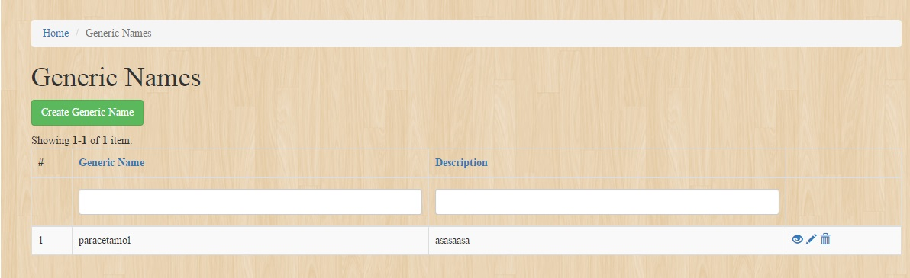

To create the Generic Name click this button



To edit or update the entity see the reference table 1.1 then click the update button.

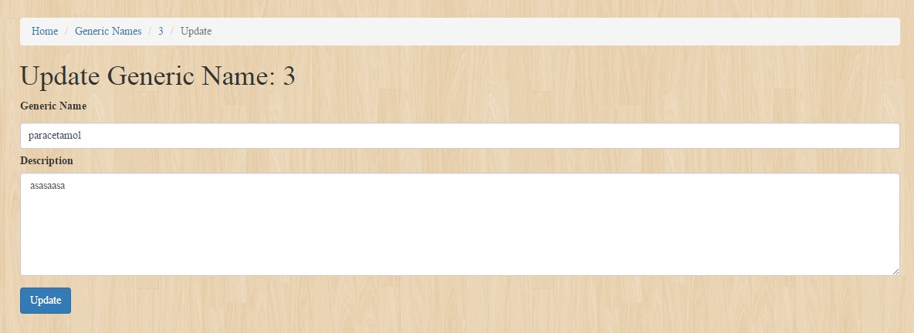

* **Manufacturer**

**Manufacturer Table**

Manufacturer table is to manage the all the Brand of the item.

The picture below is the view of the manufacturer table which is you can create, update and delete the item you will create. It shows the reference table 1.1

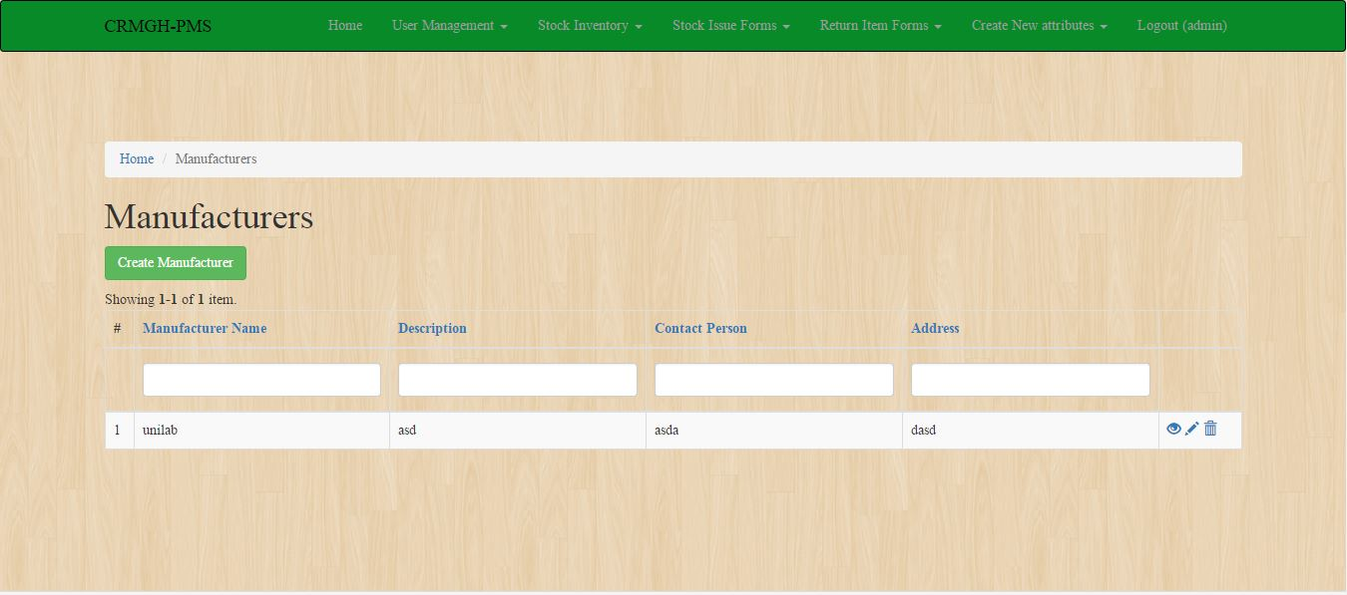

To create a Manufacturer just simply clicks this button:



It will display this page:

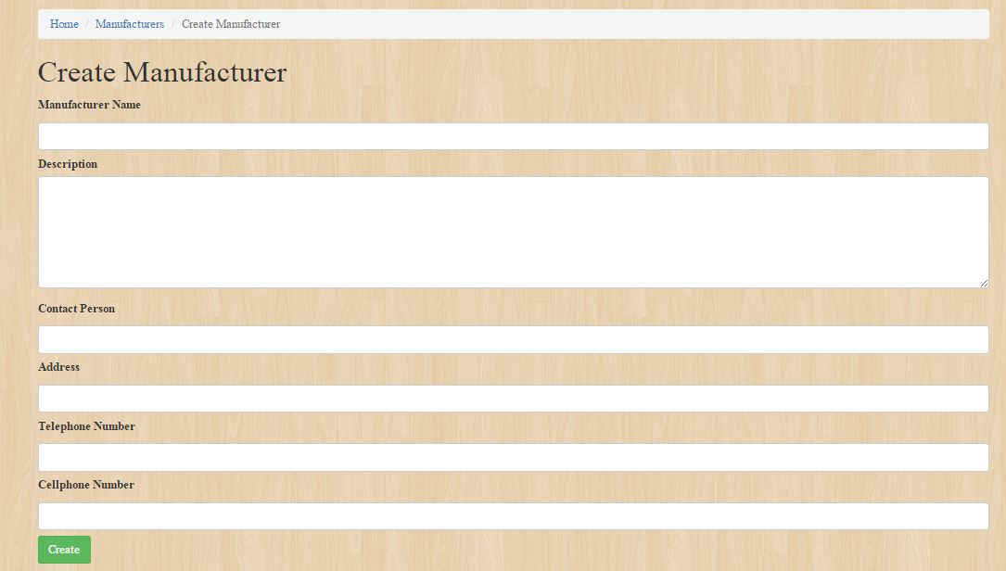

* **Unit of Measure**

**Manufacturer Table**

Manufacturer table is to manage the all the Brand of the item.

The picture below is the view of the manufacturer table which is you can create, update and delete the item you will create. It shows the reference table 1.1



To create a Manufacturer just simply clicks this button:



It will display this page:



**STOCK ISSUE FORMS TAB**

* **Stock Issue Details**

**Backend Stock Issue Details**

The picture below is to view the stock issue details which is you can create, update and delete the item you will created .It shows the reference table 1.1

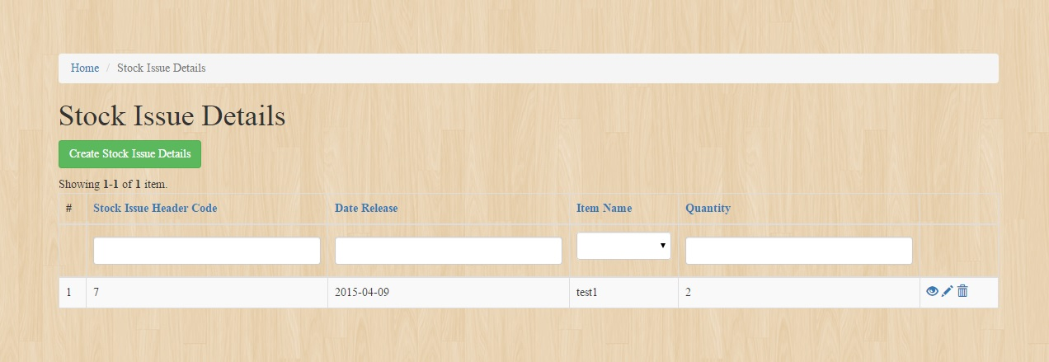

To create a stock issue details click this button.



Fill up this form to create an entity in the stock issue details.

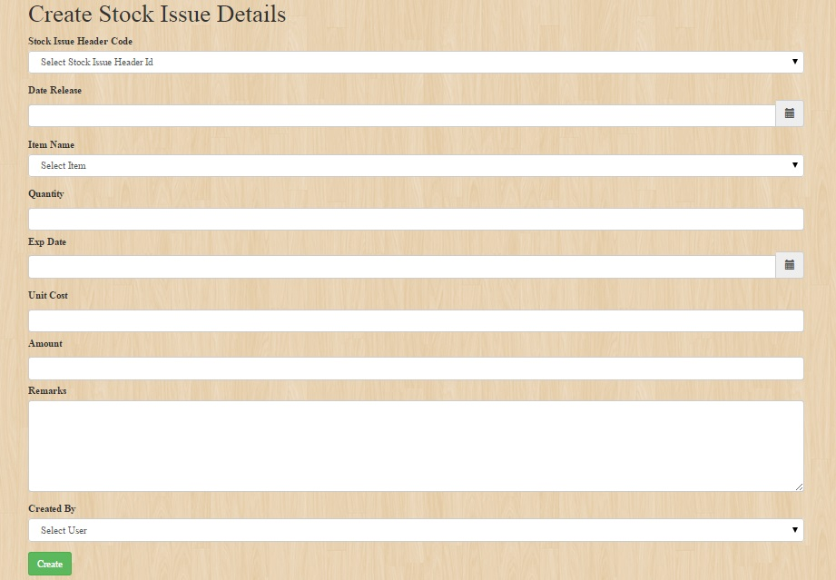

To edit or update the entity see the reference table 1.1 then click the update button.

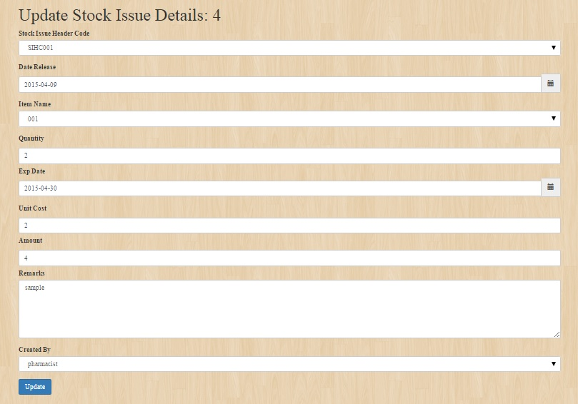

* **Stock Issue Header**

**Backend Stock Issue Header Table:**

Stock Issue Header table is to manage the all the stocks of the inventory.

The picture below is the view of the stock issue header table which is you can create, update and delete the item you will create. It shows the reference table 1.1

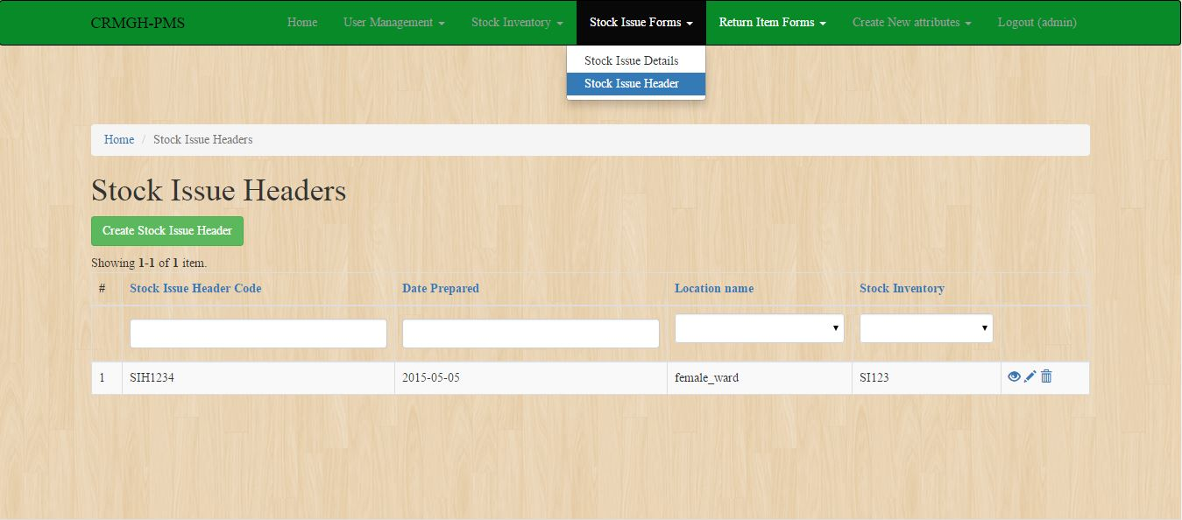

To create a Stock Issue Header just simply clicks this button:



It will display these fields:

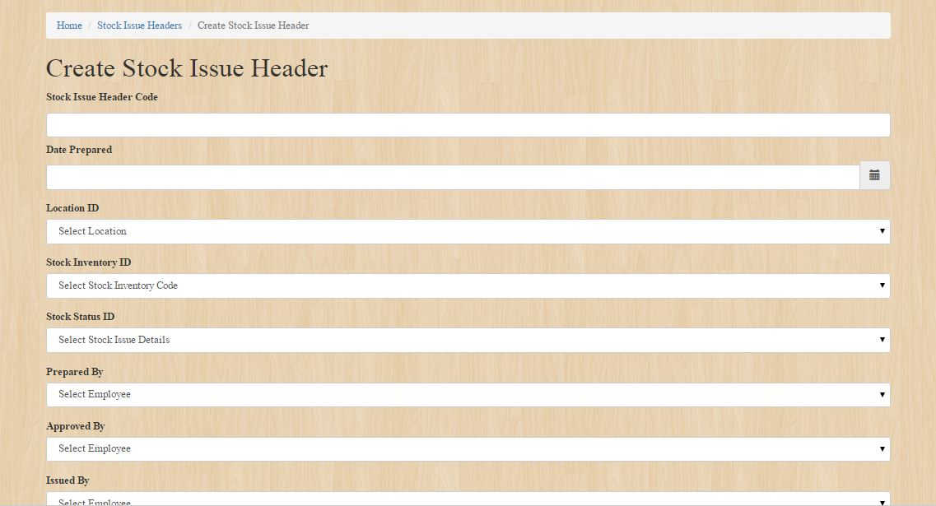

To edit or update the entity see the reference table 1.1 then click the update button.

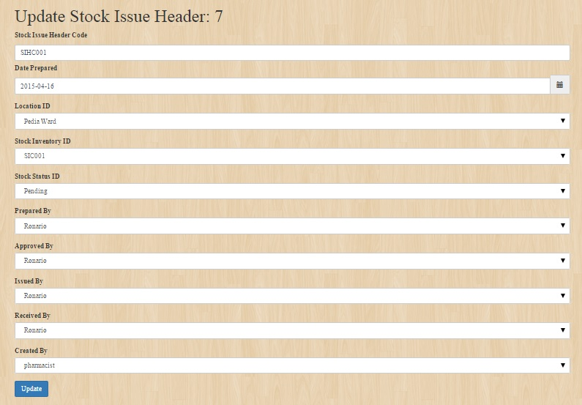

**RETURN ITEM FORMS TAB**

* **Create Patient Info**

**Backend Patient**

The picture below is to view the patient which is you can create, update and delete the item you will created .It shows the reference table 1.1

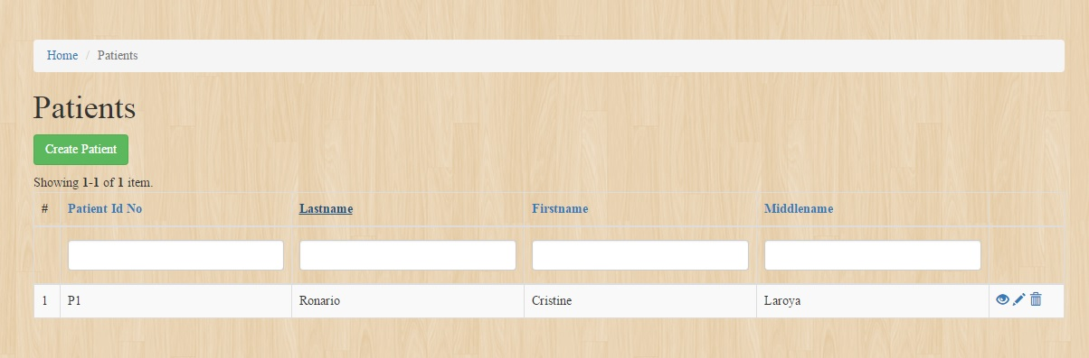

To create a patient details click this button.



Fill up this form to create an entity in the patient.

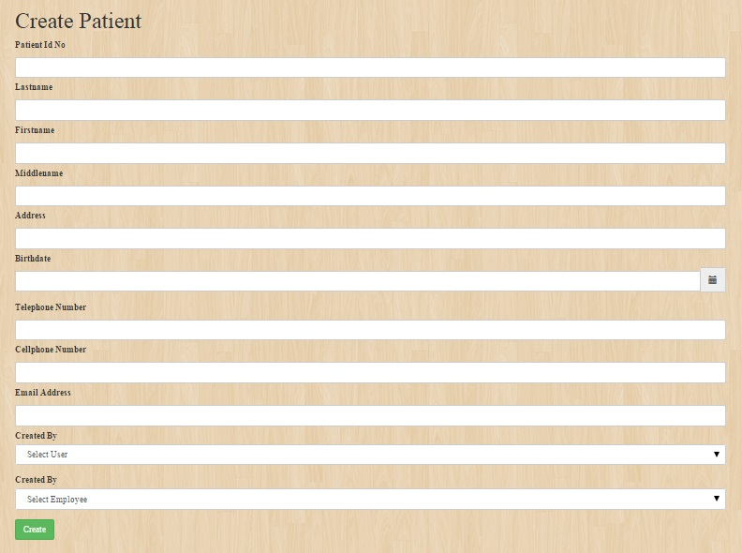

To edit or update the entity see the reference table 1.1 then click the update button.

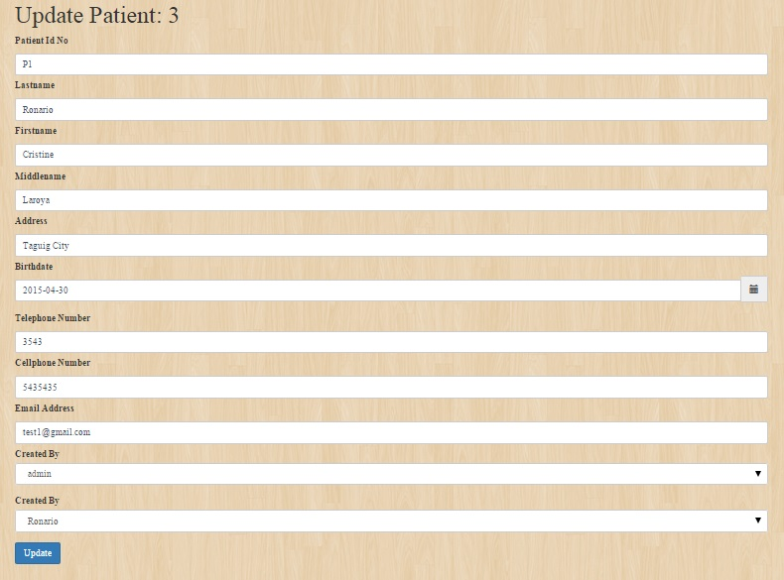

* **Return Item Details**

**Backend Return Item Details**

Under the **Return Item Forms** navigation bar, go to **Return Item Details** and the image below should be prompted which you can create, update and delete the item you will create .It shows the reference table 1.1.

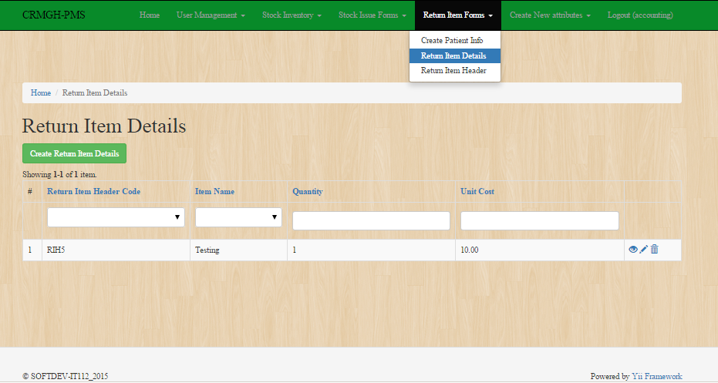

To create **Return Item Details** click the button same as the image below:



And a new page like the image below would be open as you click the **create Return Item Details** button. Fill out the fields with appropriate data and click the button **create.**

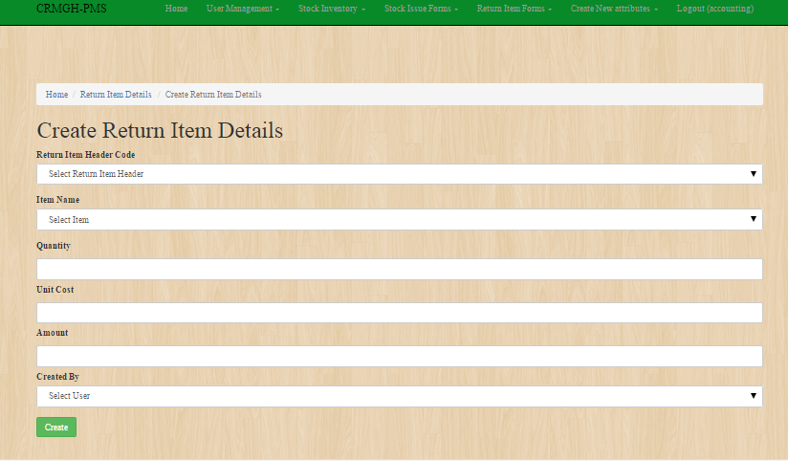

As you succesfully **created Return Item Details**, an image below should be the result.

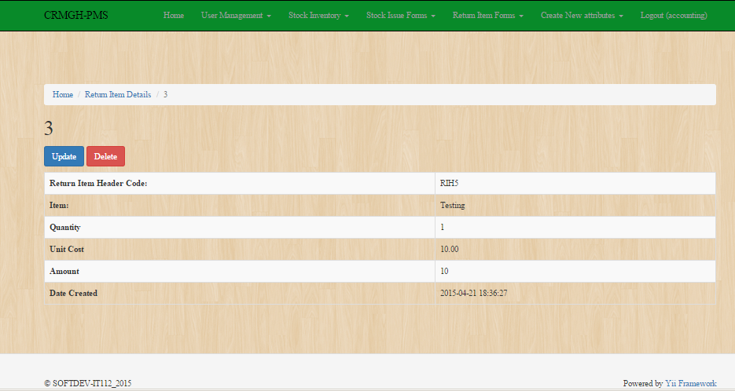

* **Return Item Header**

**Backend Return Item Header**

The picture below is to view the item category which is you can create, update and delete the item you will created .It shows the reference table 1.1

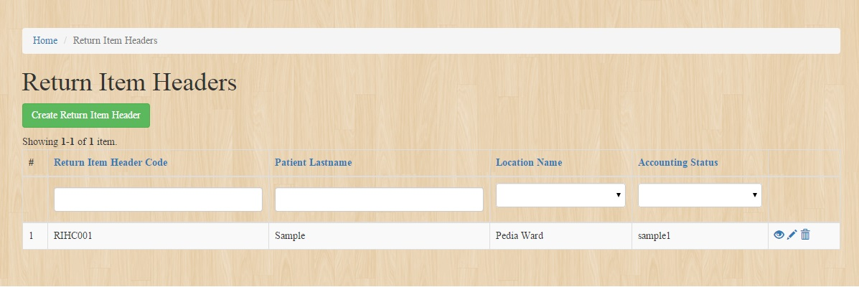

To create a Return item header details click this button.



Fill up this form to create an entity in the Return Item Header before you proceed to Return Item Details

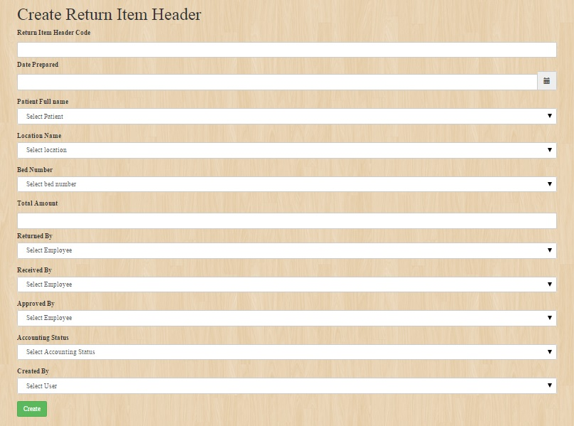

To edit or update the entity see the reference table 1.1 then click the update button.

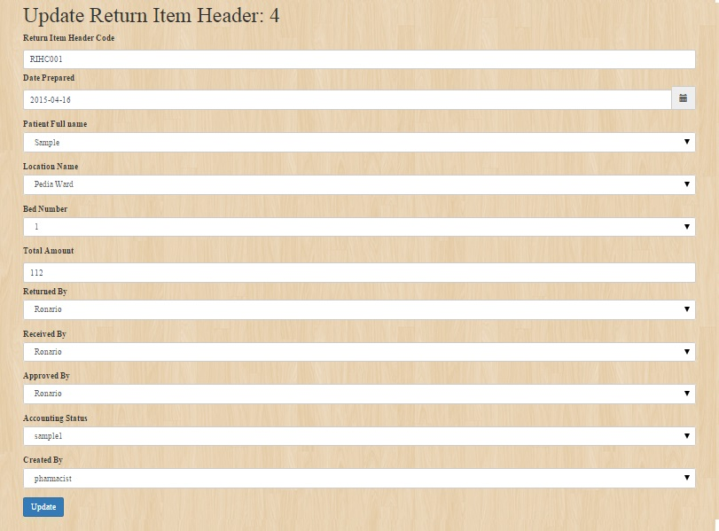

**CREATE NEW ATTRIBUTES TAB**

* **Stock Status**

**Backend of Stock Status**

Stock status is to manage the status of the stocks.

The picture below is the view of the stock status which is you can create, update and delete the item you will created .It shows the reference table 1.1

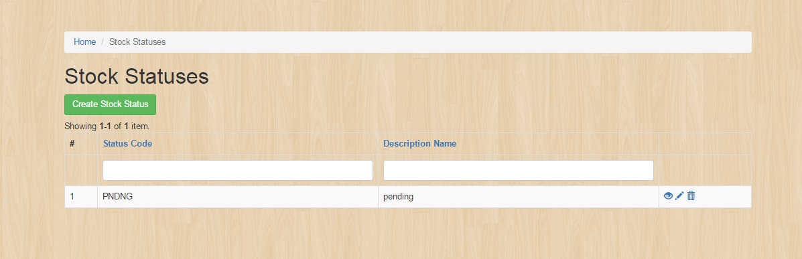

To create a Stock statuses just simply click this button

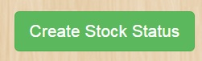

Create Stock Status for example:

1. Status code: P

Description name: Pending

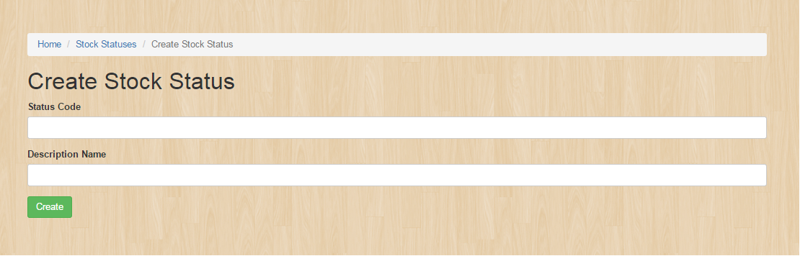

To edit or update the entity see the reference table 1.1 then click the update button.

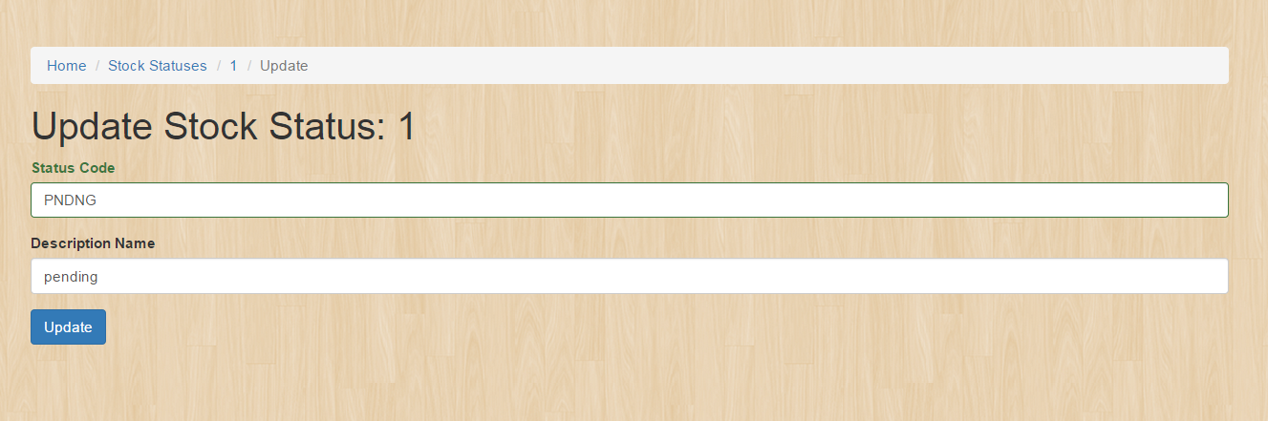

* **Accounting Status**

**Accounting Status Table:**

Accounting Status table is to manage the all the accounting status of the item.

The picture below is the view of the accounting status table which is you can create, update and delete the item you will create. It shows the reference table 1.1

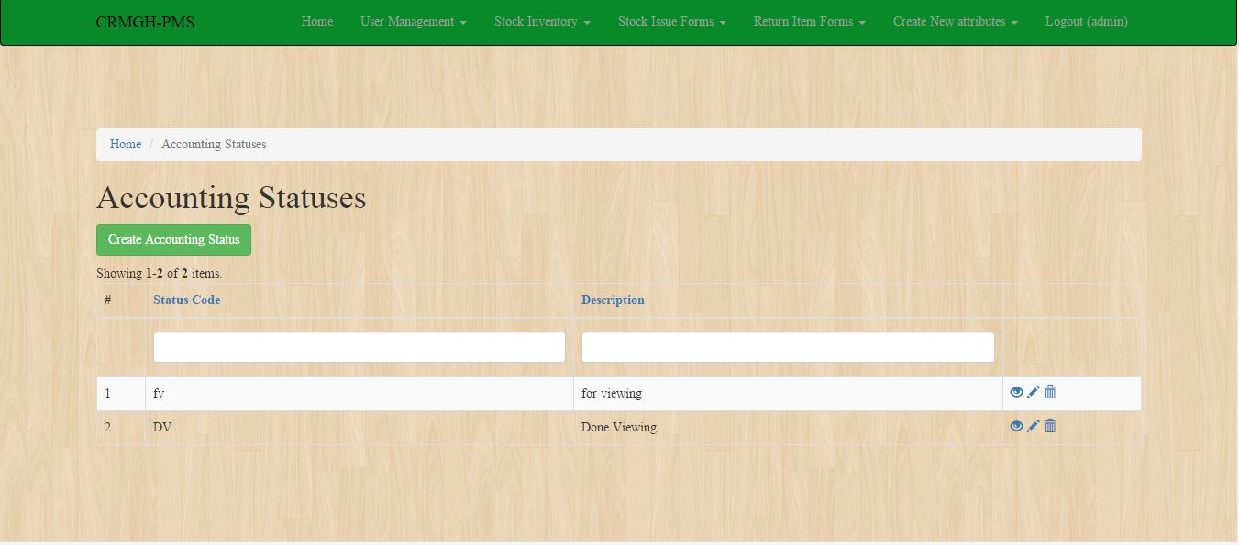

To create accounting statuses just simply click this button:



It will display this page:

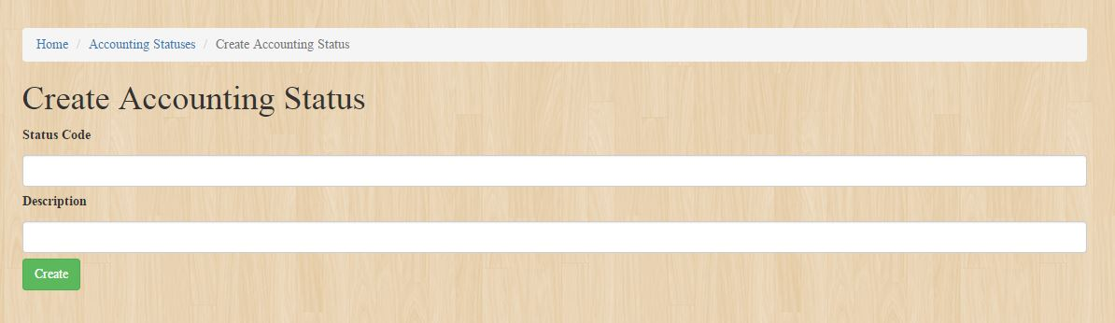

* **Location**

Location Table:

The picture below is to view the Location table which is you can create, update and delete the item you will create. It show the reference table 1.1

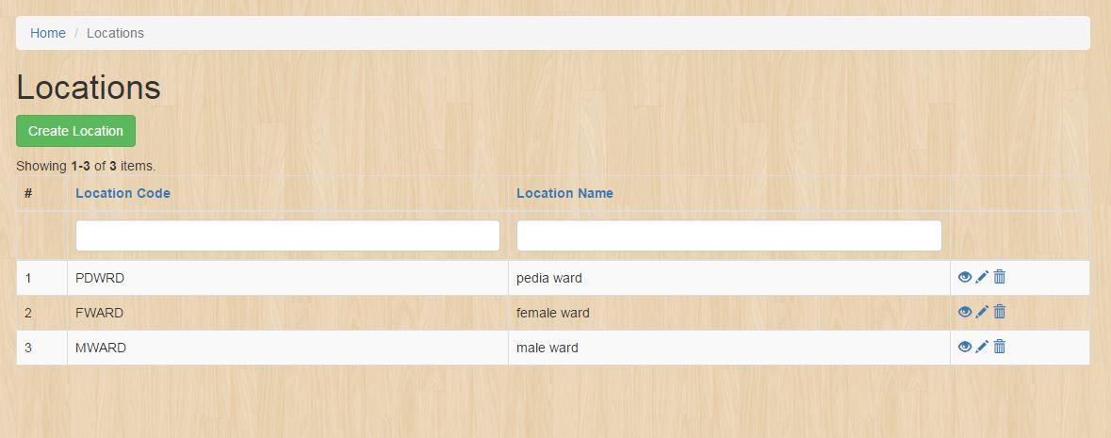

To create a Location just click this button:



Fill up this form to create an entity in the Location table:

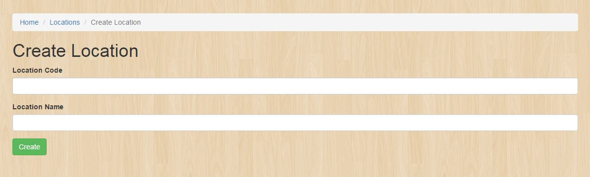

* **Bed**

**Backend Bed**

To create new **bed,** go to **create new attribute** navigation bar and click **bed,** the image below should be prompted which you can create, update and delete the item you will create .It shows the reference table 1.1.

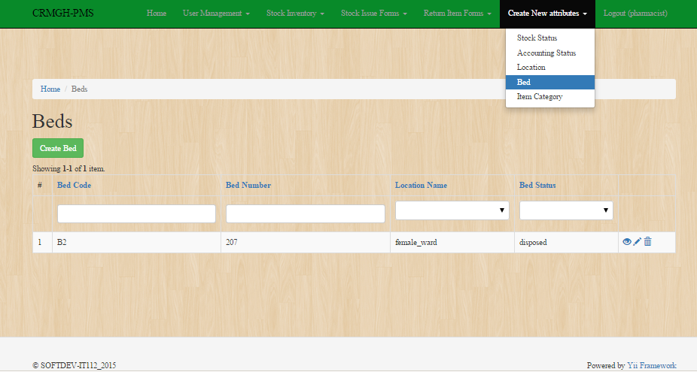

And Click the the button **create** like the image below, to create new bed.

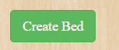

And a new page like the image below would be open as you click the **create Bed** button. Fill out the fields with appropriate data and click the button **create.**

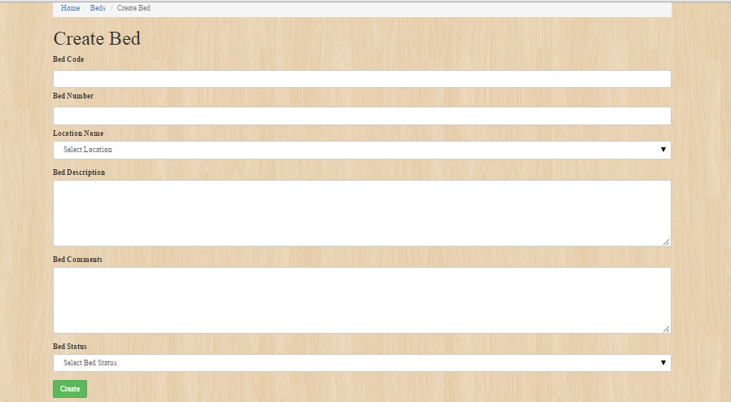

As you succesfully **created Bed**, an image below should be the result.

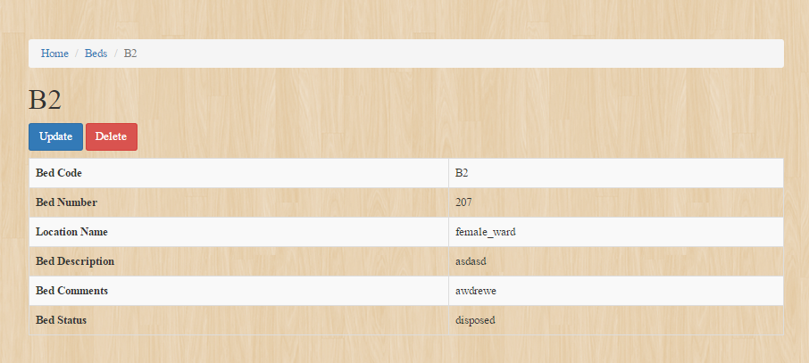

* **Item Category**

**Backend Item Category**

The picture below is to view the item category which is you can create, update and delete the item you will created .It shows the reference table 1.1

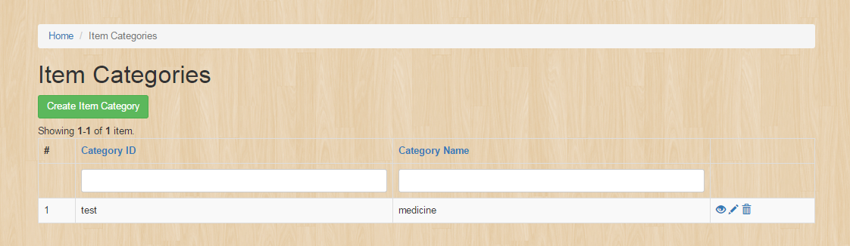

To create an item category details click this button.



Fill up this form to create an entity in the Item category.

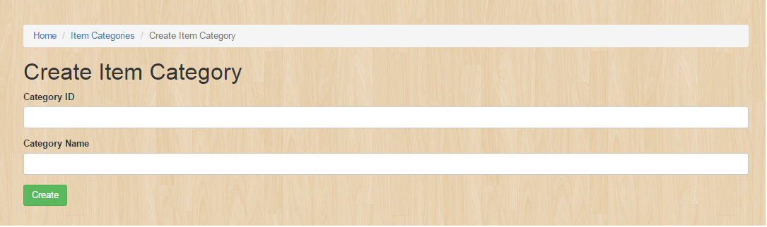

To edit or update the entity see the reference table 1.1 then click the update button.

